PRPC (Pega Rules Process Commander)

PRPC is an Automated Application Development Tool, using which we can design, develop, deploy and Run the application transaction.

PRPC provides automation of Development i.e, it has OOTB (Out Of the box 🡪 Predefined 🡪 Built in) Business Components for UI, Business Loogic and DB Queries.

PRPC Functional Transaction Process Model

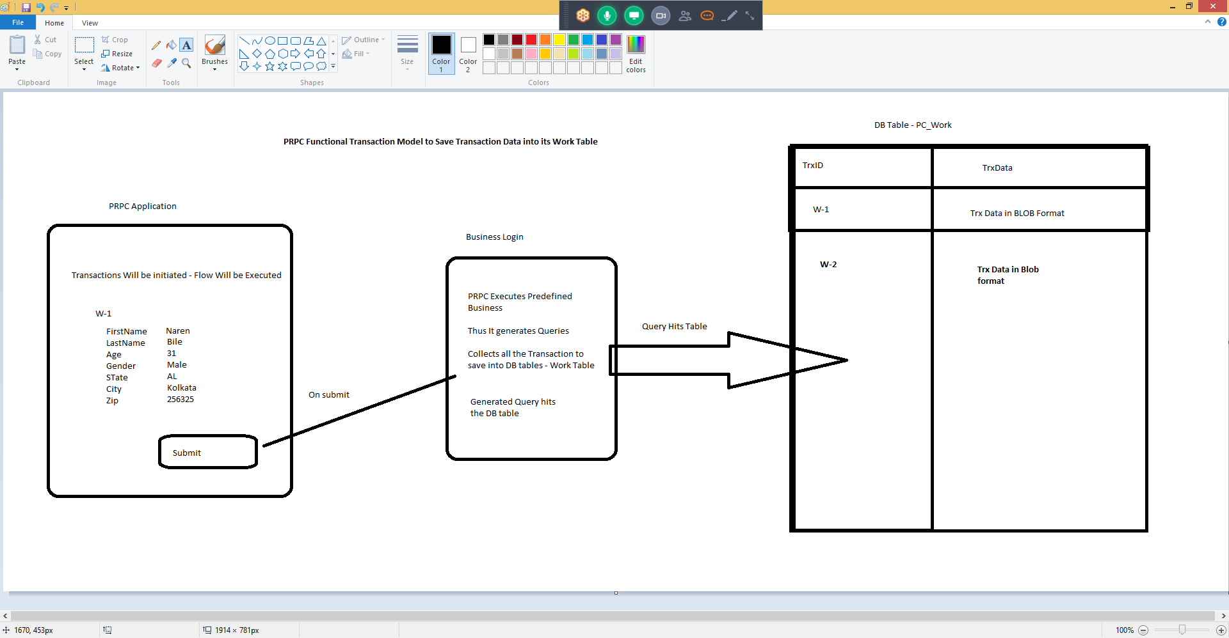

Once PRPC is installed

1. Login to PRPC using Default Credentials

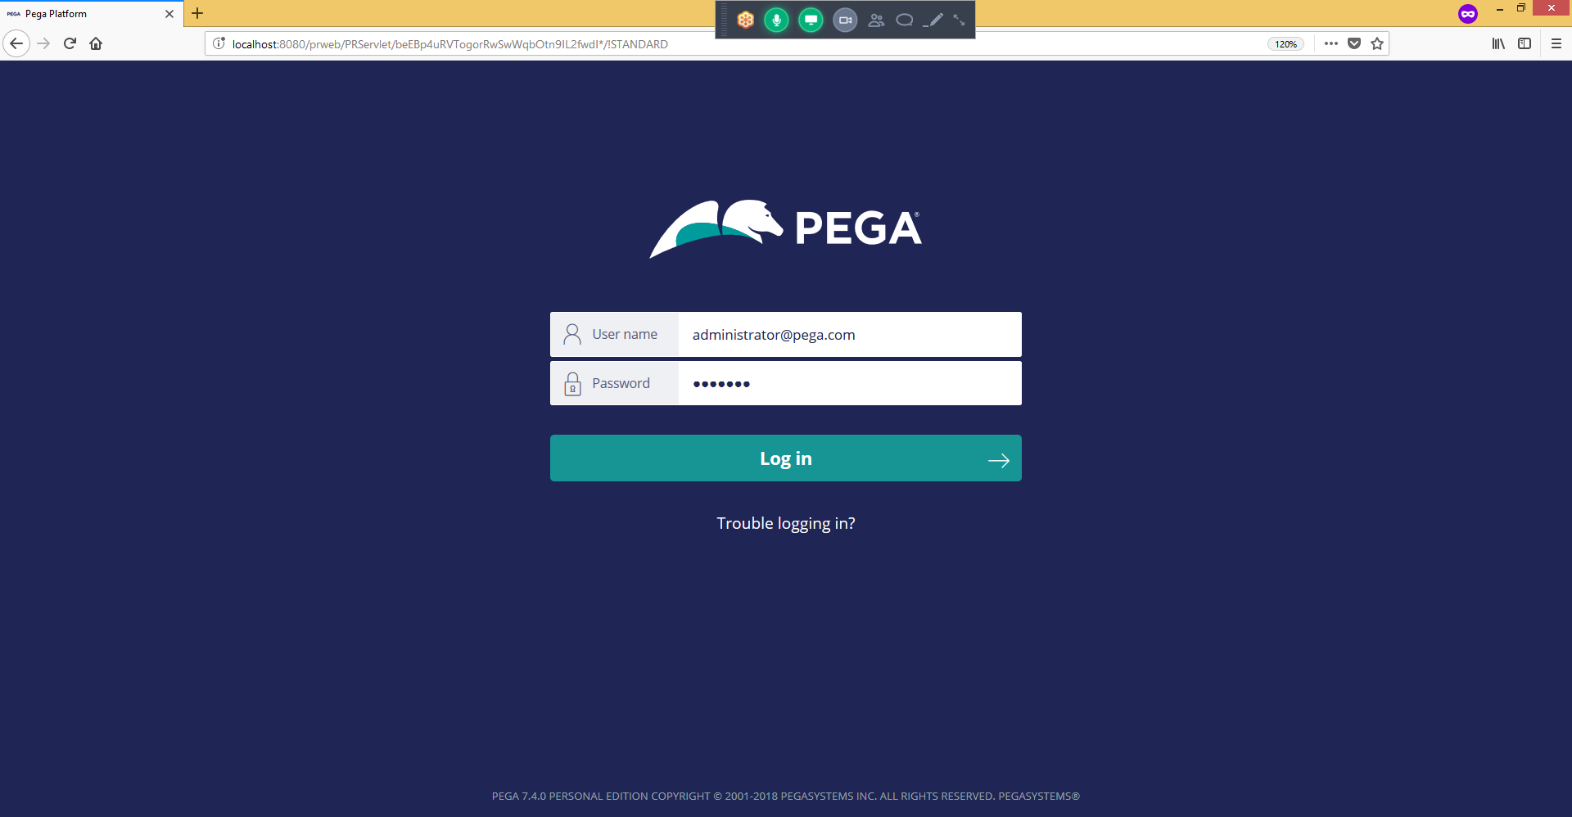

User Name : [Administrator@pega.com](mailto:Administrator@pega.com) Password : install (All Lower Case)

Operator ID :- It is the Log In ID used to login to PRPC application to access its components.

Operator :- Operator is a Person or Requestor who logs into PRPC to access its applications.

Pega Rules Process Commander

PRPC is an Application to Develop Other Applications.

In Enterprise applications the Application Layer architecture will be like Frame Work and Implementation(s).

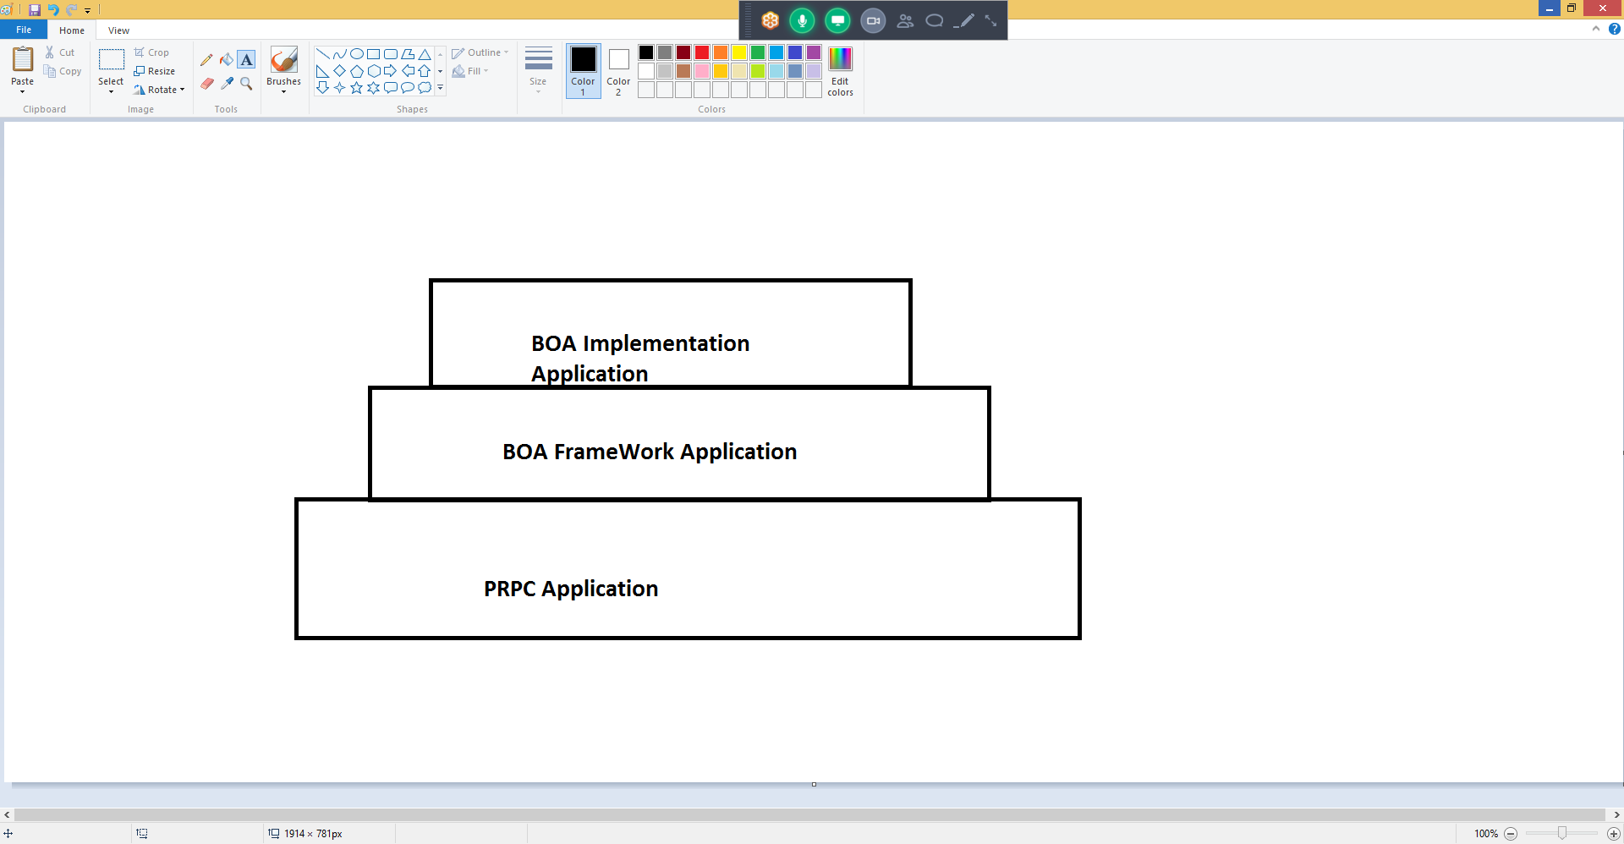

When we are creating new application,

1. We need to create Frame Work Application on top PRPC Application (Pega Rules)
2. Implementation Application on Top of Frame Work Application.

Pega Rules is a built in Application with OOTB functionalities available…

When creating our application it should be built on Pega Rules.